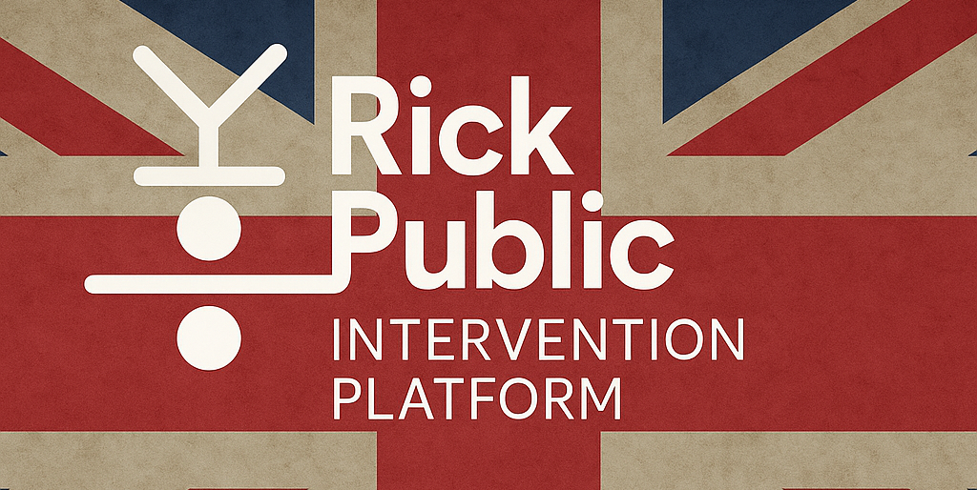

Britain Needs an Intervention
How to rescue a failing democracy without starting a new party

Britain isn’t broken, but it’s breaking.
NHS queues stretch for hours. A generation is priced out of housing. Councils go bust while ministers wage culture wars. The UK isn’t suffering from one bad policy—it’s suffering from a slow-motion collapse of competence.
This is not accidental. It’s the product of neglect, managed decline, and political theatre. And the public knows it: trust in politics has collapsed. Yet no major party offers a convincing plan.
It’s time for an intervention.
Not another party. A platform—an open, non-partisan framework for reform. Something that MPs, civic groups, journalists and voters can all get behind, while leaving behind the blame games, opinion manipulation and partisan politics.
This is UK Party Intervention Platform—five fixes to rescue Britain’s failing political operating system.

✅ The Five Fixes (Summary)
1. Rebuild Growth
Invest in digital, transport, green infrastructure; reconnect trade and skills policy with real-world productivity; re-engage with EU frameworks where possible.
2. Fix Daily Life
Regulate monopoly sectors (e.g. food, energy); shift taxes from work to lands; build homes near jobs, not just fields.
3. Rescue Public Services
Audit NHS, schools, transport systems. In-source failing contracts. Restore public sector capability with data, not dogma.
4. Heal Inequality
Introduce land value tax, baby bonds, and regional reinvestment. Close postcode lotteries in public funding.
5. Fix Democracy
Replace First Past the Post. Codify a written constitution. Create regional assemblies and citizen accountability.

1.0 Full Platform Overview
Each Fix includes concrete proposals, data-backed justifications, and public figures who already champion these issues.

1.1. Fix the Economy: Invest + Reconnect
- Reverse austerity. Fund infrastructure and skills.
- Rejoin the Single Market or EEA where feasible.
- Justification: OECD and OBR analysis show long-term scarring from low investment.
- Comparative model: Germany’s Mittelstand and infrastructure stimulus.
- Suggested Champions: David Willetts, Andy Burnham

1.2. Fix Daily Life: Regulate + Build
- Break up monopolies in food, energy, and housing development.
- Replace Council Tax and Stamp Duty with progressive land value tax.
- Build near existing transport and employment centres.
- Justification: OFGEM and CMA data show systemic failures in regulated sectors.
- Comparative model: Singapore’s housing build-to-rent scheme.
- Suggested Champions: Martin Lewis, Caroline Lucas

1.3. Rescue Public Services: Restore + Modernise
- Public audits and performance metrics.
- Insource failing outsourcing contracts (NHS IT, probation, rail).
- Use transparent digital tools to improve services.
- Justification: NAO and PAC reports show contracting inefficiencies.
- Comparative model: Scandinavia’s hybrid-service delivery.
- Suggested Champions: Rory Stewart, Wes Streeting

1.4. Heal Inequality: Redistribute + Invest
- Land Value Tax (LVT) to reduce speculation.
- Baby bonds or Sovereign Wealth participation for youth.
- Regional public investment banks to spread growth.
- Justification: IPPR and Resolution Foundation show wealth polarisation.
- Comparative model: Alaska Permanent Fund, Welsh Future Generations Act.
- Suggested Champions: Deborah Meaden, Danny Dorling

1.5. Fix Democracy: Reform + Codify
- Proportional representation for all elections.
- Introduce citizens’ assemblies for contentious issues.
- Enshrine constitutional rights in statute.
- Justification: Electoral Reform Society and Hansard Society evidence show systemic disengagement.
- Comparative model: New Zealand’s shift to MMP, Ireland’s Citizens’ Assembly.
- Suggested Champions: Neal Lawson, Jess Phillips

2.0 At-A-Glance Policy Table
Theme | Core Fixes
Growth | Green investment, market access, end austerity
Cost of Living | Anti-monopoly regulation, land tax reform, local housing supply
Public Services | Performance audits, insourcing, tech modernisation
Inequality | LVT, baby bonds, regional funding balance
Democracy | Proportional voting, citizen assemblies, codified rules

3.0 Executive Summary

Britain is spiralling. Our institutions are underfunded, our politics is performative, and our economy is flatlining. Yet the solutions are known—and supported across parties, professions, and generations.
The UK Party Intervention Platform lays out five urgent reforms. It doesn’t seek power. It seeks progress. Any MP, journalist, mayor, or citizen can endorse it—and start fixing what’s broken.
This document offers both a summary and a deep reference. It is evidence-based, cross-partisan, and designed to be adopted by anyone seeking to reform British politics with urgency, clarity, and pragmatism.

Contact: rick@groupbuild.org +1.416.414.8100

